Final Project Design Phase
Computer Science - Week 11
Oct 3, 2026 - Version 0.0.4

For complete instructions and project ideas, refer to the assignment in Canvas. Specifically, review the final project requirements before you continue below. If you have not reviewed the project requirements in Canvas (you might have to go to the modules view and check the current or past week's content), you will not be able to properly complete the parts below. In addition, it may be helpful to review the information on this Drafter documentation page.

0) Project Planning and Preparation
Successful programmers spend time planning before they begin coding. After reviewing the project requirements, answer the following questions to help guide your design and development process.
- What concepts from class or previous assignments might help you complete this project? Which programming concepts (loops, conditionals, lists, classes, etc.) do you expect to use? What programming skills do you want to improve while completing this project?
Concepts from previous assignments that I think will be helpful are helper functions (to make calculations easier), as well as for loops to help balance equations. Additionally, I think I may use dataclasses to store chemical information and conditionals to compare yields.

- Which parts of the project do you expect to be the easiest for you? The hardest? Why?
I think the hardest part will be connecting the chemistry calculations to my drafter website. I think the easiest part will be writing the helper functions

- Even though you have not yet designed the final project, estimate which tasks will likely require the most time and effort? Which features or components should be implemented first?
I think the part that will take the most time is learning how to seamlessly incorporate an external python library into my code, especially as the code becomes more complicated.

- What distractions might interfere with your work and how will you minimize them? What resources will you need available while working? What questions, if any, do you still have about the assignment requirements?
Other coursework, debugging issues , and time management are the main things I’d imagine can interfere with my work. To minimize these distractions, I’ll schedule specific blocks of time to work on my project and reach out through office hours for help when needed.

1) Site Diagram
Create a mock-up of your planned website. We suggest you make the mockup on paper, although you can also use software like PowerPoint or Slides to make a mockup. There is other design software that could also be used, but we strongly encourage you to keep it simple. Do not spend more than 15-30 minutes detailing the mock-up. Your goal should be to make a very quick and dirty diagram, to show that you have some kind of idea.

We recommend drawing each page as a rectangle, and laying out the text, buttons, and other components inside. Then, use arrows to indicate links between pages. Label each page the way you will name each function, and then put labels on the arrows to indicate what the button links. Also write down any parameters that should come into the pages.

In addition to the pages and routes, write down what fields your `State` will have, both their names and types. Think clearly about what data will need to be persistent across the entire website.

Add photo(s) or screenshot(s) of your website mock-up and labeled diagram on the next page.

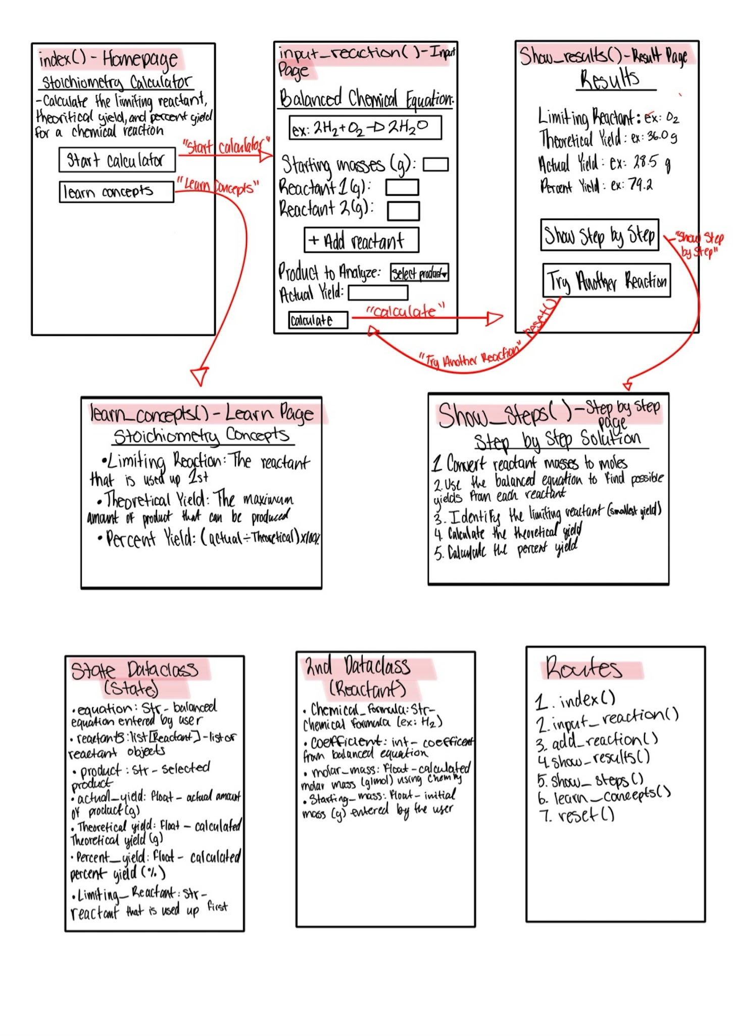
2) Implementing Requirements
This table should serve as a draft for how you will implement the requirements into your final project. You may change your ideas later on, but your final site must fulfill all the requirements.

Requirement | Implementation
Purpose/Functionality  A 1-2 sentence description of the purpose or functionality of your site | This program will consume balanced reaction equations, starting reactant masses, and product amounts and then determine the limiting reactant, theoretical yield, and percent yield.
State Dataclass Attributes  Minimum of 4 attributes, one of which must be a list/dict of instances of your second dataclass.  Briefly describe each attribute, its type, and how it will be meaningfully modified throughout the site. | -Balanced_equation (str)  - selected_product (str)  -actual_yield (float)  -reactants (list[Reactant])  - product_coefficient (int)  - product_molar_mass (float)
Second Dataclass  Your second dataclass, including its attributes, their types, and how they will be meaningfully modified (if they are modified) | Reactant:  Chemical_formula (str)- Stores the chemical formula of each reactant, entered by the user as part of the balanced equation.  coefficient(int)- Stores the reactant's coefficient from the balanced equation, which is used to calculate mole ratios.  molar_mass(float)- Stores the molar mass of each reactant, calculated using ChemPy based on its chemical formula.  starting_mass(float)- Stores the starting mass of each reactant in grams, entered by the user and used for stoichiometric calculations.
Routes (minimum 7)  The names of your route functions | index, input_reaction, save_reaction, show_results, show_steps, learn_concepts, reset_calculator, add_reactant
Pages (minimum 5)  A brief description of the pages in your site | Home, Reaction Input, Results, Step-by-Step Explanation, Learn Concepts
User Input (minimum 3)  Description of user input components (TextBox, TextArea, CheckBox, or SelectBox) and their purposes  For more information on these input types, see Drafter Documentation. | TextBoxes:  Balanced chemical equation  Reactant chemical formula  Reactant coefficient  Reactant molar mass  Reactant starting mass  Product coefficient and molar mass  Actual yield  *SelectBox (optional):  Select which product to calculate the yield for, if the reaction produces multiple products.  Students will enter each reactant's information individually and click an "Add Reactant" button to save it to a list. They can repeat this process for any number of reactants.
If Statements (minimum 3)  Brief description of what will be evaluated in your if statements and how they will meaningfully change the logic of the site | If statements will check for valid inputs, identify limiting reactants, and check if percent yield is over 100%.
Loop (minimum 1)  This loop must iterate over the list/dict of dataclass instances in your State attribute.  Description of this loop and why it is meaningful to the site | A for loop will iterate through the list of Reactant instances stored in the State dataclass. For each reactant, the program will calculate the amount of product it could theoretically produce using its starting mass, molar mass, and stoichiometric coefficient. The program will compare these amounts to identify the limiting reactant and determine the theoretical yield. This allows the calculator to work with any number of reactants.

LLM Conversation
If you used an LLM in any part of this work, copy and paste every part of that conversation below. Otherwise, you may be given a zero for the assignment. Obviously, these words will not all be yours, and this is the exception to the requirement at the top of this assignment that all responses be in your own words. If you did not use an LLM to assist you in this assignment, simply say so below.
Hi, I'm back!! could you help me. I'm writing out the specific details of the drafter website and I'm stuck on possible for loop options (I need at least one). Please help and also let me know if there's any changes I should make to any other boxes! 2) Implementing Requirements
This table should serve as a draft for how you will implement the requirements into your final project. You may change your ideas later on, but your final site must fulfill all the requirements.
Requirement | Implementation
Purpose/Functionality  A 1-2 sentence description of the purpose or functionality of your site | This program will consume balanced reaction equations, starting reactant masses, and product amounts and then determine the limiting reactant, theoretical yield, and percent yield.
State Dataclass Attributes  Minimum of 4 attributes, one of which must be a list/dict of instances of your second dataclass.  Briefly describe each attribute, its type, and how it will be meaningfully modified throughout the site. | -Balanced equation (str)  - selected product (str)  -actual yield (float)  -reactants (list[Reactant])
Second Dataclass  Your second dataclass, including its attributes, their types, and how they will be meaningfully modified (if they are modified) | Reactant:
- Chemical formula
- Coefficient
- Molar mass
- Starting mass
Routes (minimum 7)  The names of your route functions | index, input_reaction, save_reaction, show_results, show_steps, learn_concepts, reset_calculator
Pages (minimum 5)  A brief description of the pages in your site | Home, Reaction Input, Results, Step-by-Step Explanation, Learn Concepts
User Input (minimum 3)  Description of user input components (TextBox, TextArea, CheckBox, or SelectBox) and their purposes  For more information on these input types, see . | Textboxes:
- Equations
- Reactant masses
- Actual Yield
*A possible 4th for product selectiom\
If Statements (minimum 3)  Brief description of what will be evaluated in your if statements and how they will meaningfully change the logic of the site | If statements will check for valid inputs, identify limiting reactants, and check if percent yield is over 100%.
Loop (minimum 1)
This loop must iterate over the list/dict of dataclass instances in your State attribute.
Description of this loop and why it is meaningful to the site
HI HI!! Welcome back!! Your project is coming together really well, and I actually think you already have a perfect opportunity for a for loop without making the website more complicated.
I'll go through your requirements and point out what I'd keep, what I'd change, and what might cause problems when you actually start coding in Drafter.

1. Your for loop (the easiest option!)
Your State dataclass already includes:
reactants: list[Reactant]
Since your assignment requires you to iterate over a list of instances of your second dataclass, this is exactly what you should use!

Option A: Calculate the available moles of each reactant
Your loop would:
- Go through each Reactant in state.reactants.
- Access its starting_mass and molar_mass.
- Calculate the available moles.
- Use that information to help determine the limiting reactant.
Conceptually:
for reactant in state.reactants: # Calculate moles using this reactant's # starting mass and molar mass
This is probably the easiest option because you're already performing this calculation for your website.

Option B: Determine the limiting reactant
This is my favorite option because it directly connects to your project's main purpose!
Your loop would:
- Go through every reactant.
- Calculate the amount of product each could theoretically produce.
- Compare those amounts.
- Identify whichever reactant produces the least product.
For example:
Reactant | Possible product
H₂ | 10 g
O₂ | 8 g
Your loop would determine that O₂ is the limiting reactant because it produces less product.
My recommendation: Choose Option B! It satisfies your loop requirement while performing one of the most important calculations on your website.

2. State Dataclass — one change I'd consider
You currently have four attributes:
Attribute | Type | Purpose
balanced_equation | str | Stores the equation entered by the user
selected_product | str | Stores the product being calculated
actual_yield | float | Stores the experimental yield
reactants | list[Reactant] | Stores reactant information
These satisfy the minimum requirements!
However, your professor specifically asks how the attributes will be meaningfully modified throughout the site.
You could explain that the equation, product, and reactants are updated when the user submits their reaction information, while actual yield is updated when they enter their experimental results. All four can be cleared when the calculator resets.
One optional addition would be limiting_reactant: str, which would store the result of your calculation.

3. Second Dataclass — you're almost done!
I'd recommend these attributes:
Attribute | Type
chemical_formula | str
coefficient | int
molar_mass | float
starting_mass | float
Your Reactant dataclass doesn't necessarily need to be modified after creation. You could create each instance when a user enters the reactant information and update or replace it when they change their inputs.
One important consideration: How will your program obtain molar masses?
For an introductory CS project, I'd recommend letting users enter them manually rather than attempting to calculate molar masses from chemical formulas.
That avoids having to build an entire chemistry formula parser!

4. Routes and Pages — one potential issue
You have seven routes and five pages, which meets the numerical requirements.
However, I'd think carefully about the distinction between routes and pages.
Your current routes are:
index, input_reaction, save_reaction, show_results, show_steps, learn_concepts, reset_calculator
This is a reasonable plan, but save_reaction and reset_calculator are more like actions than standalone pages.
That can work in Drafter because routes can update the state and return another page.
I'd just make sure each route has a meaningful purpose.
For example, save_reaction could process the user's inputs and return the reaction input page with updated information, while reset_calculator clears the stored data and returns the home page.

5. User Inputs — one important addition!
You listed three textboxes:
- Balanced equation
- Reactant masses
- Actual yield
But your calculations also require the coefficients and molar masses of the reactants.
You have two options:
Option A: Ask users to enter the balanced equation, then manually enter each reactant's coefficient, molar mass, and starting mass.
Option B: Attempt to extract the coefficients and chemical formulas automatically from the equation.
I'd strongly recommend Option A for Intro CS.
You could still display the balanced equation at the top of the page while collecting the individual reactant details underneath.
For product selection, a SelectBox would be a nice addition, but a simple textbox is also fine.

6. If Statements — keep all three!
Your existing choices are good:
Condition | Program behavior
Invalid input | Display an error message and ask the user to correct it
One reactant produces less product | Identify it as the limiting reactant
Percent yield exceeds 100% | Display an explanation that experimental error or impurities may be involved
I'd make the first condition more specific: check for zero or negative molar masses, invalid coefficients, or negative starting masses before performing calculations.
That will help prevent division-by-zero errors.

7. One chemistry detail worth planning now
To calculate theoretical yield, you'll also need the product's coefficient and molar mass.
Your Reactant dataclass stores reactant information, but your selected product is currently only a string.
The simplest solution would be to add product_coefficient: int and product_molar_mass: float to your State dataclass.
That way, you can use the mole ratio:
\[ \text{Product moles}=\frac{\text{Reactant moles}}{\text{Reactant coefficient}}\times\text{Product coefficient} \]
Then multiply by the product's molar mass to find its theoretical yield.

My overall recommendation
I would keep your current five pages, seven routes, and three if-statement ideas. I'd use the limiting-reactant comparison loop, add product coefficient and molar mass to your State, and have users manually enter the chemical information instead of building a formula parser.
That gives you a realistic Intro CS project that still teaches students meaningful chemistry.
One question before you finalize your table: Are you planning to let students enter reactions with any number of reactants, or would you be comfortable limiting the calculator to reactions with exactly two reactants?
That decision will make a big difference in how complicated your Drafter website becomes.
any number of reactants
OHH okay!! Then your for loop becomes even more useful, because you won't know how many reactants the user will enter!
The good news is that your existing list[Reactant] is perfect for this. You won't need separate calculations for two, three, or four reactants.

How I'd implement it
Your website could have an Add Reactant button that allows students to enter as many reactants as necessary.
Each reactant would have:
- Chemical formula (str)
- Coefficient (int)
- Molar mass (float)
- Starting mass (float)
When the student clicks Calculate, your program loops through state.reactants to determine how much product each reactant could produce.
Example: Comparing three reactants
Reactant A
12 g
Reactant B
Limiting
8 g
Reactant C
15 g
Illustrative possible product yields, not starting reactant masses.

What to put in your Loop requirement box
A for loop will iterate through the list of Reactant instances stored in the State dataclass. For each reactant, the program will calculate the amount of product it could theoretically produce using its starting mass, molar mass, and stoichiometric coefficient. The program will compare these amounts to identify the limiting reactant and determine the theoretical yield. This allows the calculator to work with any number of reactants.

Two small changes I'd make to your other boxes
State Dataclass: Your reactants: list[Reactant] can grow whenever the user adds another reactant. I'd also consider adding product_coefficient: int and product_molar_mass: float so your program can calculate the theoretical yield.
Routes: Since you want unlimited reactants, consider replacing one of your existing routes or adding add_reactant and remove_reactant. These would let users build and modify their reactant list.
One important detail: In Drafter, you'll need a way to collect the inputs for each new reactant. The easiest beginner-friendly design is to have one set of reactant input boxes and an Add Reactant button, then display the saved reactants underneath. Students can repeat this process as many times as needed.
That keeps the project flexible without requiring complicated dynamic forms.
I'd actually recommend implementing the Add Reactant functionality first when you start coding, because it establishes your second dataclass, your State list, and one of your most important routes all at once!

Final Submission
When you are finished, download this file as a Word Document (docx) and upload the file to the appropriate assignment on Canvas.

